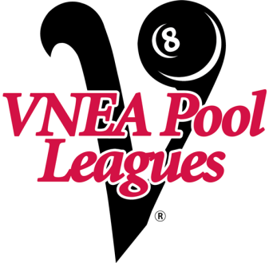

LORAIN FALL 8 BALL LEAGUE
MEETING
SEPTEMBER 11TH
ELYRIA MOOSE
555 TERNES ST. ELYRIA
7:30 PM
IF YOU CAN NOT ATTEND PLEASE CALL THE OFFICE
440-366-9529 EXT 210

