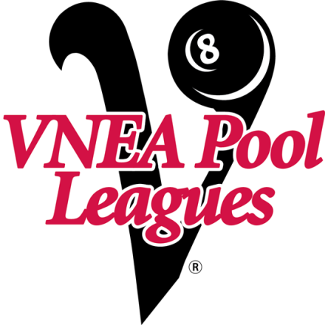

LORAIN COUNTY SUMMER POOL LEAGUES
MEETING
MAY 22, 2019
AT LAPORTE INN
2092 GREFTON RD, ELYRIA
7:00PM
FOR MORE INFO CONTACT
TERESA 440-366-9529 EXT 210

